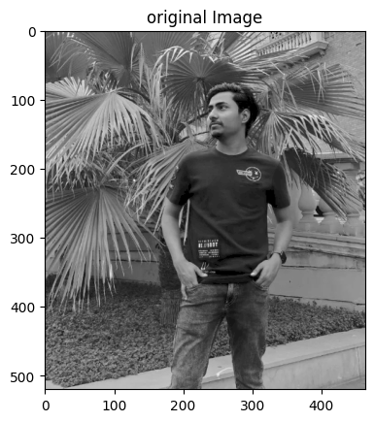Q3  
Part A  
 Size: (520, 464)

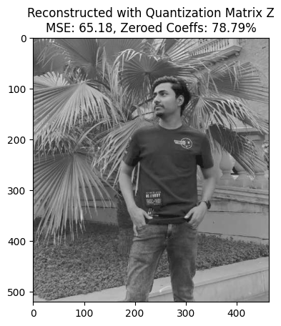

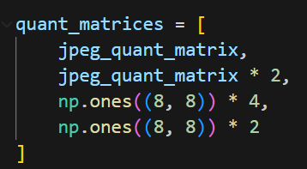four different choices of Z:

Part B

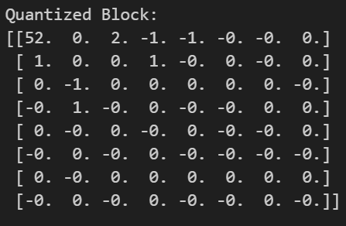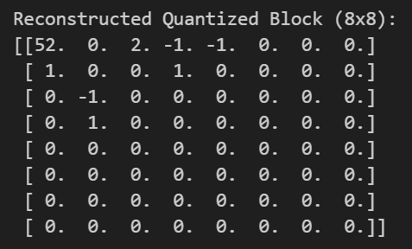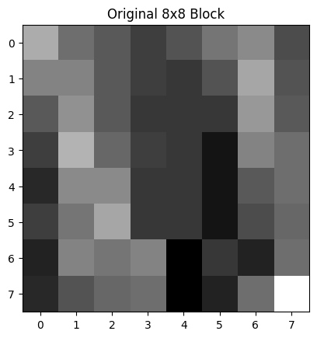

Compression Ratio: 7.11

Part C:

Entropy = 5.322022440750344

Average Huffman Code Length = 5.3470720966626635

Part D:

Entropy = 5.250353436975073

Average Huffman Code Length = 5.27453870509881

Part E:

final compression ratio = 6.65928371576329